**Monster Descriptions :**

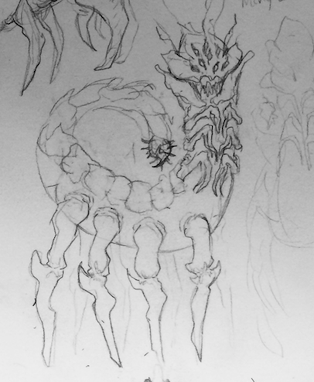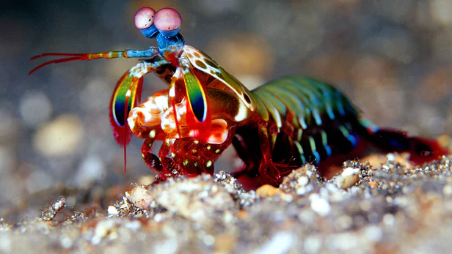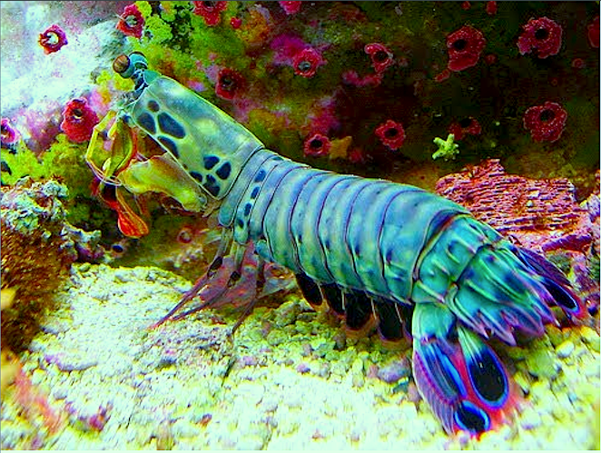**Main Monster :**

**Scientific classification name :** Stomatopoda Terramillipedes, from the **Crustacea** family. **(STEPHEN)**

This creature while colourful is one of the most violent BLU Crop has dealt with since it’s foundation. It’s large size and hard armoured exterior made is especially hard to sedate and capture. Keeping is constantly sedated for learning is required. It is a seemingly solitary species, living on the remote volcanic islands in the southern hemisphere. It is able to withstand extreme heat and pressures like the interior of active volcanoes. They stand around 8 times the size of the average human, they are extremely strong and agile and will eat anything that moves. It has multiple eyes and seems to see using heat signatures.

Interacting with this creature is highly discouraged.

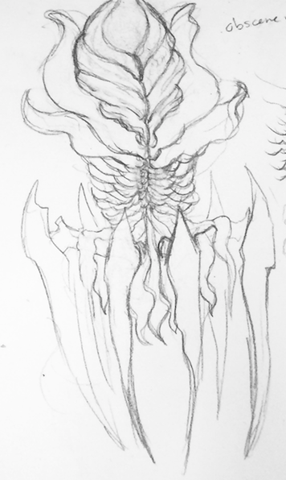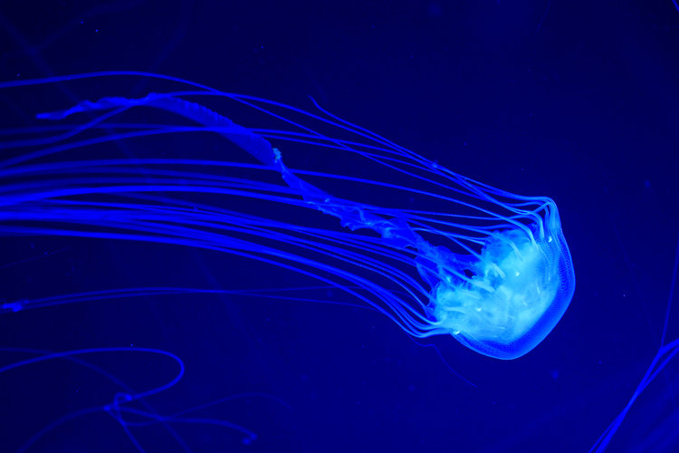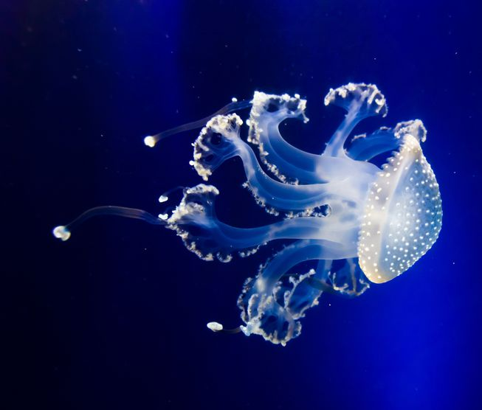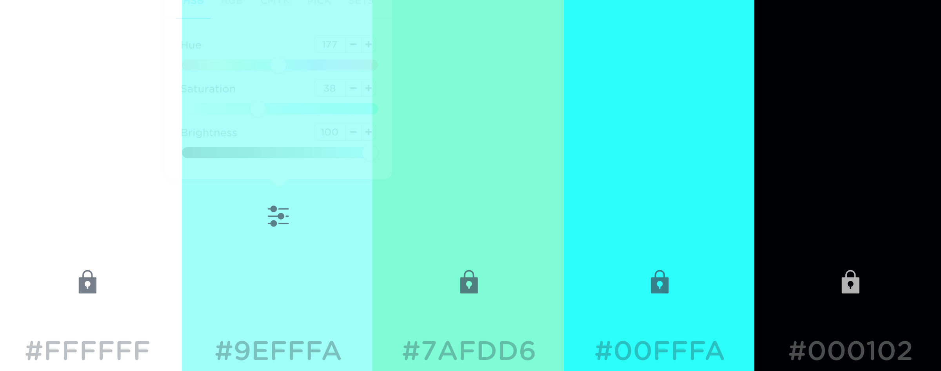

**Monster 2 :**

**Scientific classification name :** Atolla Nonarma, from the **Atollidae** family.  **(NONA)**

Atolla Nonarma is a deep sea, octopus/jellyfish/spider crab like creature. It is difficult to find as it is mostly translucent in any light but in the dark it’s visible by its bioluminescence. It stands about 2 times the height of the average human, it is a slow moving, docile creature as meals on the seafloor are few and far between. It crawls the bottom of the ocean luring scavengers and other bottom feeders with its bioluminescence. The gentle/flowing movement of the extremities draw other animals in towards the center of Atolla Nonarma’s chest (which has the highest concentration of bioluminescence), where they enter through a hole into the hollow cavity. Once inside, similar to a Venus fly-trap, the entrance is sealed and digestive fluids are secreted and the unfortunate animals are then slowly digested.

These creatures see to have hypnotic qualities, interacting with them without a tether is highly discouraged.

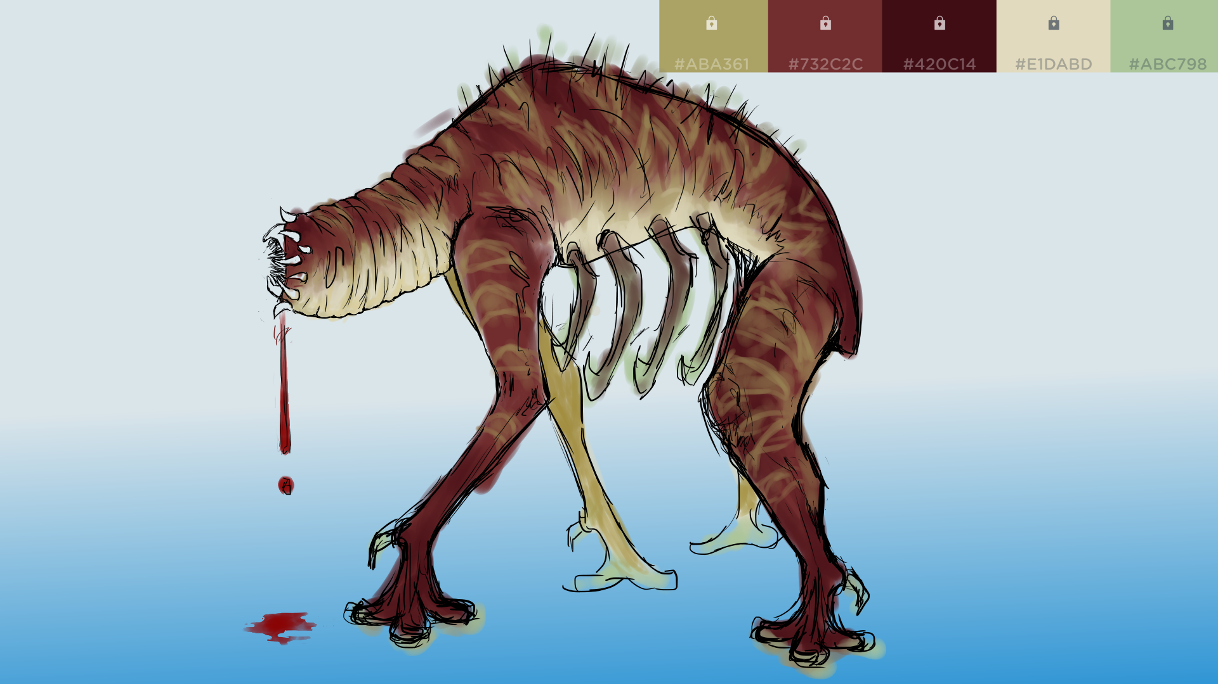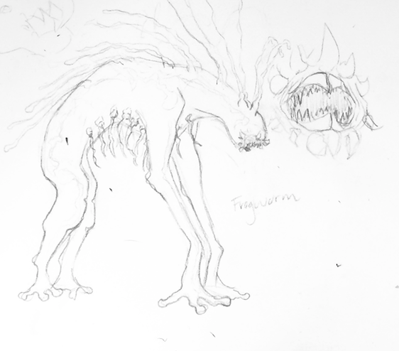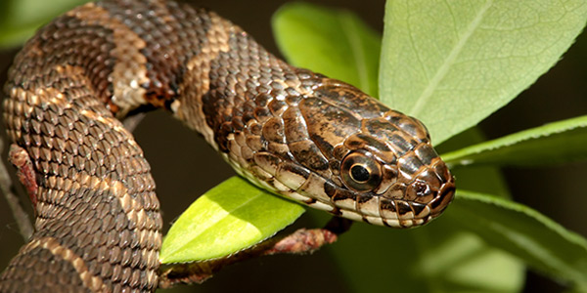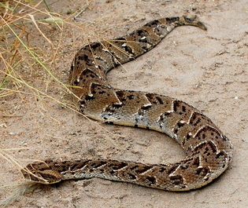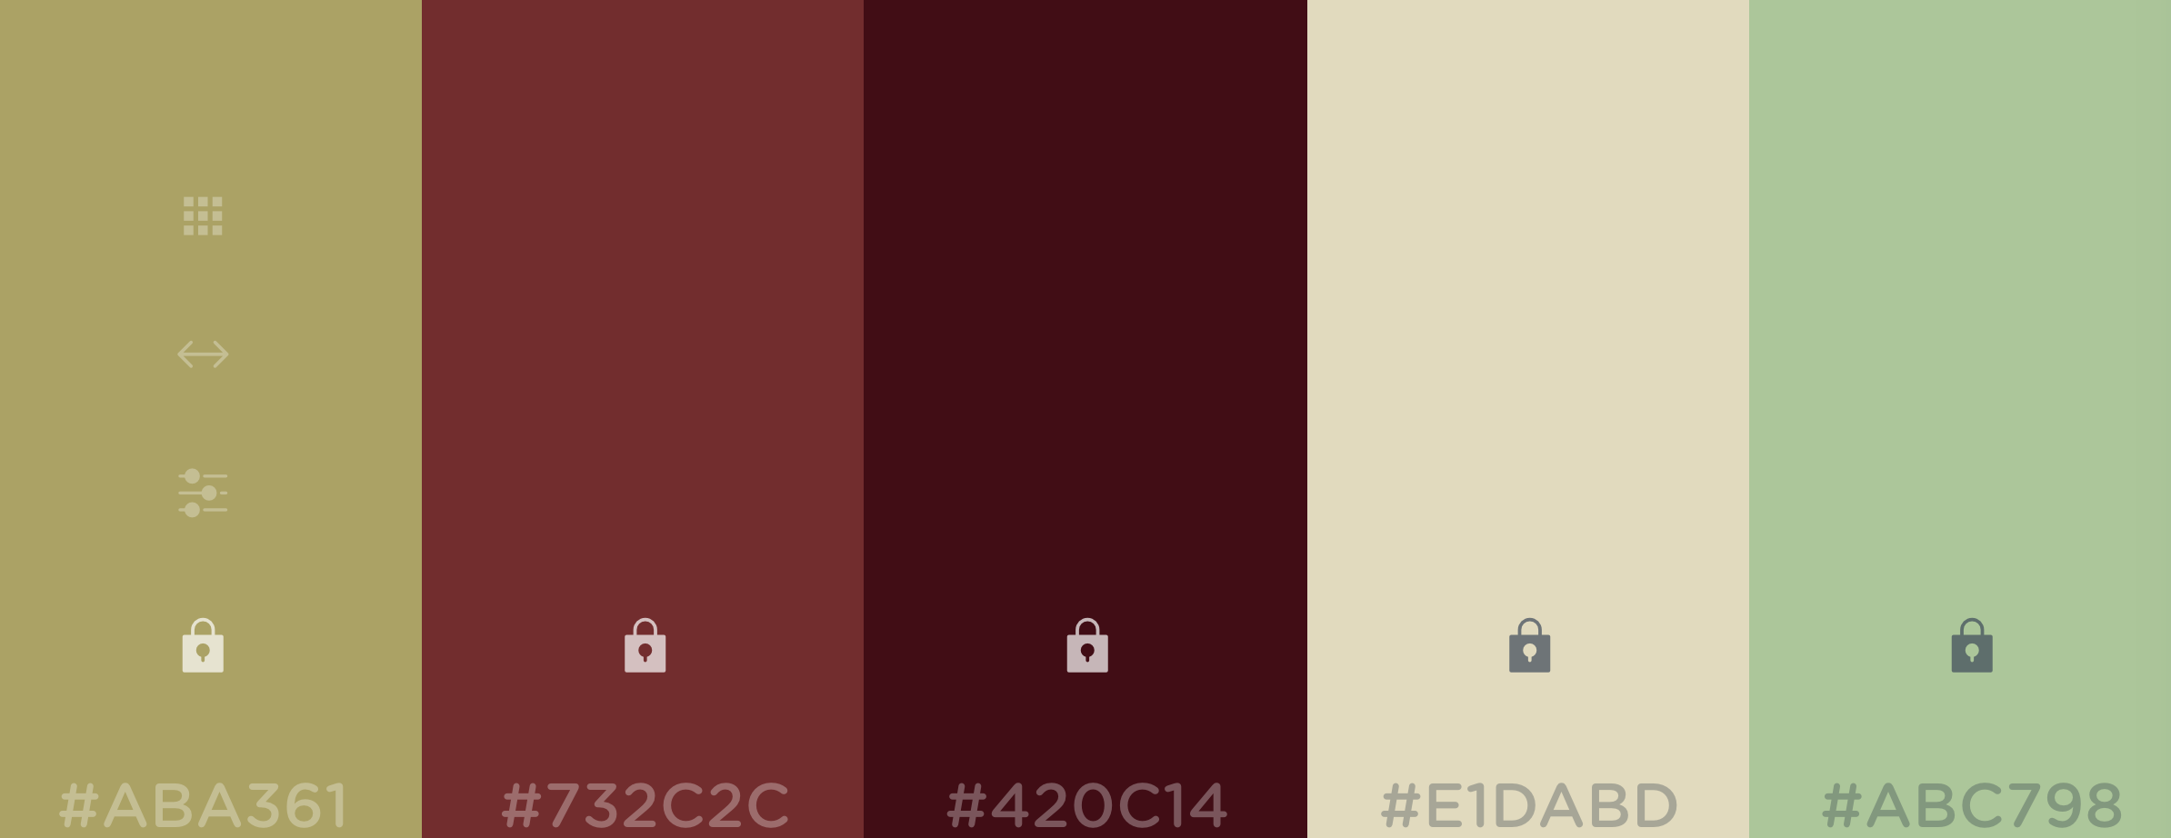

Monster 3 :

**Scientific classification name :** Nematoda Animcomedenti, yet to receive family classification **(NEMA)**

A

Nematoda Animcomedenti is a land quadrupedalism found in tropical climates, in heavily forested areas. It is covered in a moist scale like skin that is a mix of browns and greens, giving it great camouflage in its natural habitat. Standing ¼ the size a human it is a fast moving pack hunter. Consisting of packs of 10-15 these creatures will surround and consume their prey in a matter of minutes, by latching themselves onto the prey. Using their 4 long, frog like appendages they will approach the prey quietly before jumping onto them. At this point they will stab the claw like appendages, underneath their bellies, into the prey to attach themselves. Pulling the Nematoda Animcomedenti off of the prey is nearly impossible if they reach this point as their claws are very strong and go very deep into the prey. The final step of the Nematoda Animcomedenti attachment to the prey is when they burrow their head into the prey’s tissue. At this point they begin to suck all the fluids from the host. Any harder structures are sprayed with a strong, acid like fluid from their mouths, that turns those structures into a soup for consumption by Nematoda Animcomedenti.

These creatures will attack anything, interacting with them without sedation is highly discouraged.